Warrior Wednesday 4/8

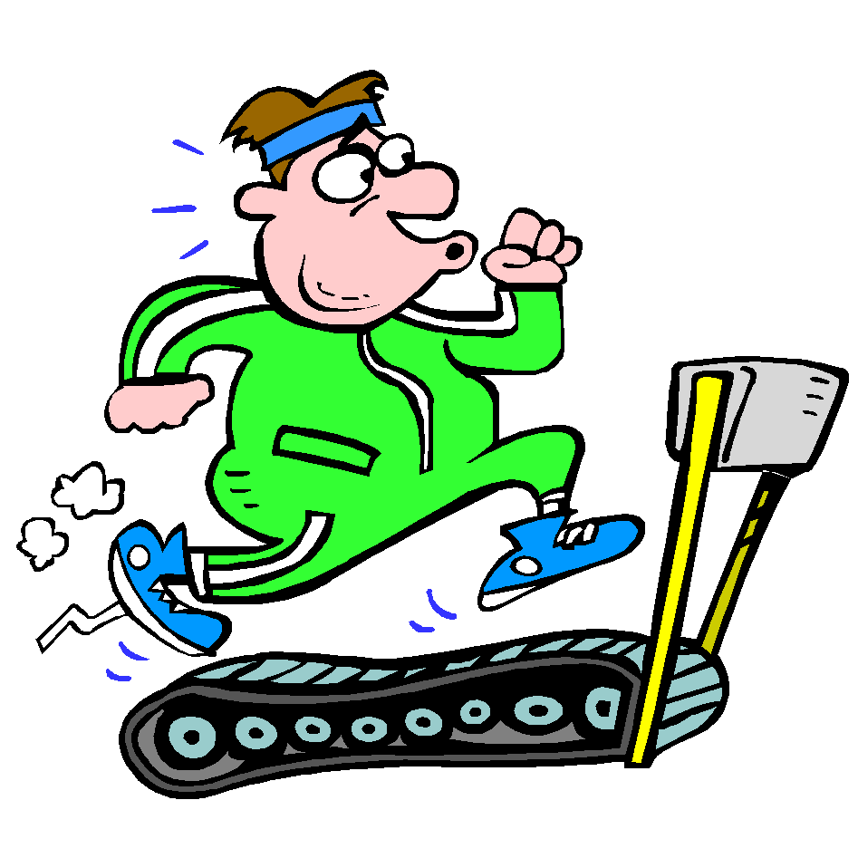

**If you are not sure how to perform one of the exercises below please click the following link, and simply type in the name of the exercise for instructions**

<https://workoutlabs.com/exercise-guide/>

**ARMS and ABS – Perform each 1x through – TRY MORE SETS IF YOU WISH =) --- Go through the Arm Workout 1st, before moving onto Abs.**

**Equipment:** Dumbbells or Water Bottles/Canned Goods

|  |  |  |  |
| --- | --- | --- | --- |
| Arms | Reps | Abs | Reps |
| Pushups | 20 | High Plank Shoulder Taps | 100 |
| Alternating Hammer Curls | 10 | Mountain Climbers | 90 |
| Bicep Curls (1/2 Way Up) | 10 | Russian Twists | 80 |
| Bicep Curls (1/2 Way Down) | 10 | Scissor Kicks | 70 |
| Shoulder Press | 20 | Reverse Crunch | 60 |
| Lying Chest Fly | 15 | Heel/Ankle Taps | 50 |
| Front Raises | 10 | Bicycles | 40 |
| Single Arm Rows | 15 | Side Crunch | 30 (15 per side) |
| Incline Pushup | 10 | Straight Leg Raises | 20 |
| Tricep Extension | 15 | Burpees | 10 |

**---Stretch and Hydrate ---**

**Spell Your Name Workout:** First and Last Name

A – 20 High Knees

B – 20 Cross Punches

C – 20 Glute Bridges

D- 20 Skaters/Lateral Hops

E – 2 stair runs/ 20 Bunny Hops

F – 20 Big Arm Circles (10 Forward/10 Backwards)  
 G – 20 Skaters/Lateral Hops

H – 10 Star Jumps/Tuck Jumps

I – 25 Jumping Jacks

J – 20 Cross Punches

K – 20 High Knees

L – 15 Pushups

M – 20 Crunches

N – 10 Burpees

O – 20 Bicycles

P – 20 Toe Touch Crunches

Q – 20 Shoulder Taps

R – 2 Stair Runs/20 Bunny Hops

S – 20 Glute Bridges

T – Small Arm Circles (10 Forward/10 Backwards)

U – 20 (1 Leg forward/backward hops – 10 each side)

V – 20 High Knees

W – 20 Jumping Jacks

X – 20 Glute Kicks

Y – 20 Cross Punches

Z – 10 Burpees

-STRETCH and HYDRATE-