Warrior Wednesday 4/15

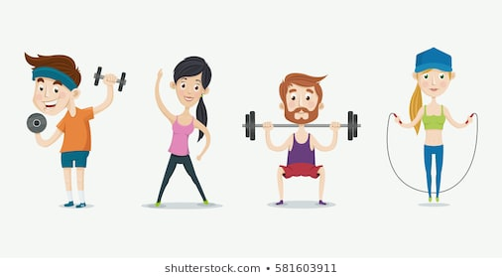

**If you are not sure how to perform one of the exercises below please click the following link, and simply type in the name of the exercise for instructions**

<https://workoutlabs.com/exercise-guide/>

**Full Body Workout:**

**Equipment:** Dumbbells or Water Bottles/Canned Goods

|  |  |  |  |  |  |
| --- | --- | --- | --- | --- | --- |
| Circuit 1 | Circuit 2 | Circuit 3 | Circuit 4 | Circuit 5 | Circuit 6 |
| :30 Squats | :30 Curtsy Lunge | :30 Alt. Single Leg Deadlift w/ Row | :30 Bridge w/ Chest Fly | :30 Straight Leg Crunch | :30 Hammer Curl |
| Alternating Shoulder Press  x8 Each Side | Reverse Fly  X 12 | Tricep Kickback  X 8 Each Side | Superman  X8  *Hold @ top for 5 Sec | Bicycle  X10 Each Side | Tricep Pushup  X 8 |
| :30 Burpees | :30 Jumping Jacks | :30 Quick Feet | :30 Plank | :30 Mountain Climber | :30 Squat Jump |
| Repeat x2 | Repeat x2 | Repeat x2 | Repeat x2 | Repeat x2 | Repeat x2 |
| Rest 1:00 | Rest 1:00 | Rest 1:00 | Rest 1:00 | Rest 1:00 | Complete |

**---Stretch and Hydrate ---**

**No Equipment Warrior Wednesday: 3 Rounds for Time**

**\*See how long it takes you to get through 3 rounds of this workout\***

* 50 Jumping Jacks
* 10 Squats
* 10 Sumo Squats
* 50 Alternating Punches
* 50 Russian Twists
* 20 Alternating Lunges w/ Twist
* 20 Alternating Side Lunge
* 40 Bicycle Crunches
* 20 Alternating Knee to Elbow
* :60 Plank

-STRETCH and HYDRATE-