Workout of the Day - Thursday 4/16

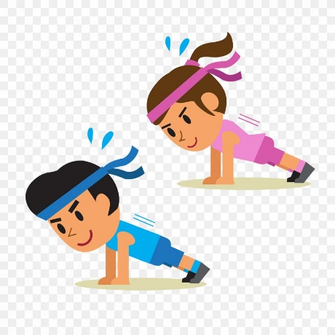

**If you are not sure how to perform one of the exercises below please click the following link, and simply type in the name of the exercise for instructions**

<https://workoutlabs.com/exercise-guide/>

**Full Body Workout:**

**Equipment:** Dumbbells or Water Bottles/Canned Goods

|  |  |  |
| --- | --- | --- |
| Cardio Warmup – 1 Round | Upper Body – 3 Rounds | Lower Body – 3 Rounds |
| 50 Jumping Jacks | 20 Reverse Grip Bicep Curls | 20 Lunge Jumps |
| 30 High Knees | 20 Skull Crushers | 30 Crunches |
| 20 Glute Kicks | 20 Overhead Press | 20 Walking Lunges |
| 10 Speed Skaters | 10 Lateral Raise | 10 Straight Leg Raises |
| Rest :30 | Rest and Repeat x 2 | Rest and Repeat x 2 |

**---Stretch and Hydrate --**

**Total Body Countdown: 2 Rounds**

* 100 Squats -50 Mountain Climbers
* :90 Plank -40 Jumping Lunges
* 80 Walking Lunges -30 Pushups
* 70 Bicycles -20 V-Ups
* 60 Tricep Dips -10 Burpees

-STRETCH and HYDRATE-