Tuesday 4/7 – Workout of the Day

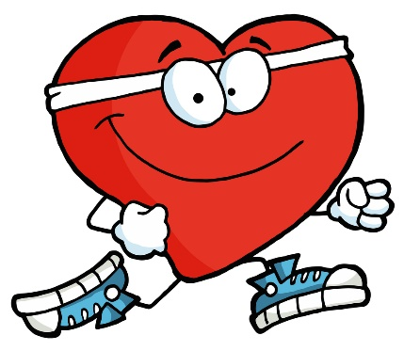

**If you are not sure how to perform one of the exercises below please click the following link, and simply type in the name of the exercise for instructions**

<https://workoutlabs.com/exercise-guide/>

**Head/Shoulders/Knees/Toes: Perform each circuit 1x through**

**Equipment:** Dumbbells or Water Bottles/Canned Goods

|  |  |  |  |  |  |
| --- | --- | --- | --- | --- | --- |
| Circuit 1 | Circuit 2 | Circuit 3 | Circuit 4 | Circuit 5 | Circuit 6 |
| 60 Jumping Jacks | 60 Jumping Jacks | 60 Jumping Jacks | 60 Jumping Jacks | 60 Jumping Jacks | 60 Jumping Jacks |
| 15 Skull Crushers | 15 Lateral Raises | 15 Plie’ Squats | 15 Bent Over Row | 15 Sumo Squats | 15 Mountain Climbers |
| 15 Should Press | 15 Goblet Squat | 20 Lunges | 15 Pushups | 15 Glute Bridges | 15 Burpees |
| 15 Tricep Extension | 15 V-Ups | 15 Calf Raises | 15 Alternating Bicep Curls | 15 Deadlift | :60 Plank |
| Rest | Rest | Rest | Rest | Rest | Complete |

**---Stretch and Hydrate ---**

**No Equipment Tabata:**

* 20 Seconds Exercise; 10 Second Rest
* 4 Rounds of Each Circuit (4:00 each circuit, 16 minutes total)

|  |  |  |  |
| --- | --- | --- | --- |
| Tabata 1 | Tabata 2 | Tabata 3 | Tabata 4 |
| Jumping Jacks | Skater Jumps | Squat Thrusts | Mountain Climbers |
| Pushups | Tricep Dips | Arm Circles | Walkouts (Inchworms) |
| High Knees | Lunges | Glute Kicks | Burpees |
| Wall Sit | Crunches | Flutter Kicks | Plank |
| Rest | Rest | Rest | Complete |

-STRETCH and HYDRATE-