Thursday 4/9 – Workout of the Day

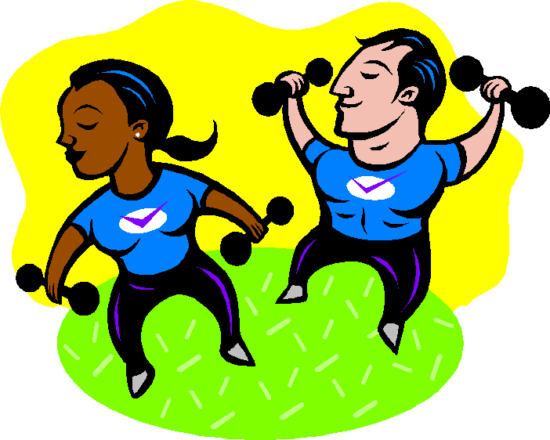

**If you are not sure how to perform one of the exercises below please click the following link, and simply type in the name of the exercise for instructions**

<https://workoutlabs.com/exercise-guide/>

**Total Body Circuit:** Repeat each circuit 3x each

**Equipment:** Dumbbells or Water Bottles/Canned Goods

|  |  |  |  |
| --- | --- | --- | --- |
| **Circuit 1** | **Circuit 2** | **Circuit 3** | **Circuit 4** |
| 20 Squats | 20 Walking Lunges | 20 Sumo Squat | 20 Side Lunges |
| 15 Shoulder Press | 15 One Arm Row | 15 Upright Row | 15 Decline Pushups |
| 15 Reverse Grip Bicep Curl | 15 Standing Chest Fly | 15 Alternating Front Raise | 15 Tricep Dip |

**---Stretch and Hydrate ---**

**No Equipment Ladder:**

**Reps: 20-18-16-14-12-10-8-6-4-2**

**Exercise: Lunges – Burpees – Situps - Pushups**

-STRETCH and HYDRATE-